**Battleship Game – Design & Feedback Documentation**

**(1) Design Phase – Wireframes**

I created the Battleship game interface wireframes using pencil, highlighters, and paper. These sketches show the app’s core screens and user flow, emphasizing clarity, interaction, and UI structure.

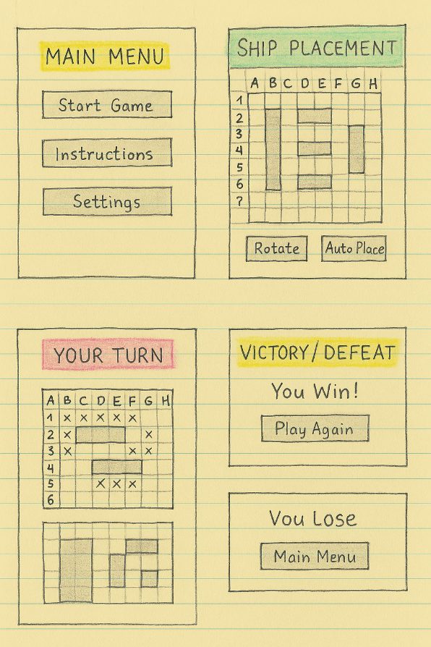

**Breakdown of Screens**

**1. Main Menu**

* **Buttons**:
  + Start Game
  + Instructions
  + Settings
* **Purpose**: Launch point for all actions.

**2. Ship Placement**

* **Grid**: 10×10 player board (labeled A–H, 1–7).
* **Ships**: Manually place or auto-place.
* **Controls**:
  + Rotate button
  + Auto Place button

**3. Your Turn (Gameplay)**

* **Top Grid**: Opponent board (X marks attacks).
* **Bottom Grid**: Player board with ships and hits.
* **Goal**: Take turns targeting opponent's grid.

**4. Victory/Defeat**

* **Messages**:
  + “You Win!” or “You Lose”
* **Actions**:
  + Play Again
  + Return to Main Menu

**(2) Review Session**

I held a live session with:

* 2 classmates (tech-savvy)
* 1 casual player (non-technical)

They roleplayed a game using the wireframes, offering insights on usability, layout, and game flow. Notes were taken on the wireframes and typed below.

**Feedback Based on Criteria**

| **Category** | **Reviewer Feedback Summary** |
| --- | --- |
| **Clarity** | Clear screens and structure. Suggested stronger labeling for grids. |
| **Completeness** | All features present. Pause functionality could be added. |
| **Consistency** | Buttons and layout consistent across all screens. |
| **Scalability** | Design supports future features like multiplayer, difficulty modes, or AI. |
| **Usability** | Suggested adding tap-to-place option for mobile. Gameplay screen was intuitive. |
| **Requirements Adherence** | Fully meets the Battleship functionality criteria. |
| **Technical Feasibility** | Easily implemented with HTML/CSS/JS or React. Grids should use CSS grid or canvas. |
| **Optimization** | Use reusable components for grid and button controls. |
| **Security Considerations** | Multiplayer will need input validation and anti-cheat mechanics. |
| **Creativity & Innovation** | Loved the color-coded sections and suggested animations for hits/misses. |

**References:**

Brown, T. (2009). *Change by design: How design thinking creates new alternatives for business and society*. Harvard Business Press.  
<https://www.harvard.com/book/change_by_design/>

Gothelf, J., & Seiden, J. (2013). *Lean UX: Applying lean principles to improve user experience*. O’Reilly Media.  
<https://www.oreilly.com/library/view/lean-ux/9781449311650/>

Saffer, D. (2010). *Designing for interaction: Creating smart applications and clever devices* (2nd ed.). New Riders.  
<https://www.peachpit.com/store/designing-for-interaction-creating-smart-applications-9780321643394>